**1. Create an Android Application to accept a number and display the multiplication table.**

**(Use table Layout)**

Code: main.xml

*<?*xml version="1.0" encoding="utf-8"*?>*<ScrollView xmlns:android="http://schemas.android.com/apk/res/android"  
 xmlns:app="http://schemas.android.com/apk/res-auto"  
 xmlns:tools="http://schemas.android.com/tools"  
 android:layout_width="match_parent"  
 android:layout_height="match_parent"  
 tools:context=".MainActivity">  
  
 <LinearLayout  
 android:layout_width="match_parent"  
 android:layout_height="match_parent"  
 android:orientation="vertical">  
 <TextView  
 android:layout_width="wrap_content"  
 android:layout_height="wrap_content"  
 android:id="@+id/txtview1"  
 android:text="Multiplication Table"  
 android:textStyle="bold"  
 android:textSize="25sp"  
 android:layout_marginLeft="100dp"  
 android:layout_marginTop="15dp"  
 android:textColor="#000080"/>  
 <EditText  
 android:layout_width="match_parent"  
 android:layout_height="wrap_content"  
 android:id="@+id/etnum"  
 android:hint="Enter a number"  
 android:inputType="number"  
 android:layout_marginTop="15dp"  
 android:layout_marginLeft="15dp"  
 android:layout_marginRight="15dp"/>  
 <EditText  
 android:layout_width="match_parent"  
 android:layout_height="wrap_content"  
 android:id="@+id/etrange"  
 android:hint="Enter the range"  
 android:inputType="number"  
 android:layout_marginTop="15dp"  
 android:layout_marginLeft="15dp"  
 android:layout_marginRight="15dp"/>  
 <Button  
 android:layout_width="wrap_content"  
 android:layout_height="wrap_content"  
 android:id="@+id/showbtn"  
 android:text="Display"  
 android:layout_marginTop="15dp"  
 android:layout_marginLeft="150dp"/>  
 <TableLayout  
 android:layout_width="match_parent"  
 android:layout_height="match_parent"  
 android:layout_marginTop="15dp">  
 <TableRow  
 android:layout_width="match_parent"  
 android:layout_height="wrap_content">  
 <TextView  
 android:id="@+id/txtview2"  
 android:layout_width="250dp"  
 android:layout_height="wrap_content"  
 android:layout_marginTop="15dp"  
 android:layout_marginLeft="15dp"  
 android:text=""/>  
 </TableRow>  
 </TableLayout>  
 </LinearLayout>  
</ScrollView>

Code: MainActivity.Java

package com.example.mulltitable;  
  
import androidx.appcompat.app.AppCompatActivity;  
  
import android.os.Bundle;  
import android.view.View;  
import android.widget.TextView;  
import android.widget.Button;  
import android.widget.EditText;  
  
public class MainActivity extends AppCompatActivity {  
 EditText e1,e2;  
 Button b1;  
 TextView t1;  
 int num,range;  
  
  
 @Override  
 protected void onCreate(Bundle savedInstanceState) {  
 super.onCreate(savedInstanceState);  
 setContentView(R.layout.*activity_main*);  
 e1=findViewById(R.id.*etnum*);  
 e2=findViewById(R.id.*etrange*);  
 t1=findViewById(R.id.*txtview2*);  
 b1=findViewById(R.id.*showbtn*);  
 b1.setOnClickListener(new View.OnClickListener() {  
 @Override  
 public void onClick(View v) {  
 t1.setText("");  
 showResult();  
 }  
 });  
 }  
 private void getdata()  
 {  
 String i=e1.getText().toString().trim();  
 String j=e2.getText().toString().trim();  
 if(i.isEmpty())  
 {  
 e1.setError("Required");  
 }  
 else if(j.isEmpty())  
 {  
 e2.setError("Required");  
 }  
 else {  
 try {  
 num= Integer.*parseInt*(i);  
 } catch (NumberFormatException e) {  
 e.printStackTrace();  
 e1.setError("Not a number");  
 }  
 try {  
 range = Integer.*parseInt*(j);  
 } catch (NumberFormatException e) {  
 e.printStackTrace();  
 e2.setError("Not a number");  
 }  
 }  
 }  
 private void showResult()  
 {  
 getdata();  
 for (int a=1;a<=range;a++)  
 {  
 String prt=num+"*"+a+"="+(num*a)+"\n";  
 t1.append(prt);  
 }  
 }  
  
}

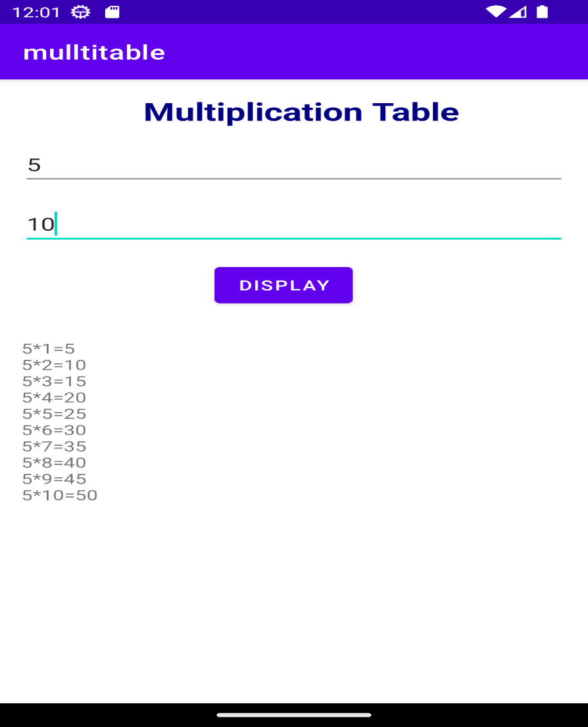

**2. Create a Simple Application which shows the Life cycle of Activity.**

**Xml code**

*<?*xml version="1.0" encoding="utf-8"*?>*<androidx.constraintlayout.widget.ConstraintLayout xmlns:android="http://schemas.android.com/apk/res/android"  
 xmlns:app="http://schemas.android.com/apk/res-auto"  
 xmlns:tools="http://schemas.android.com/tools"  
 android:layout_width="match_parent"  
 android:layout_height="match_parent"  
 tools:context=".MainActivity">  
  
 <TextView  
 android:layout_width="wrap_content"  
 android:layout_height="wrap_content"  
 android:text="Hello World!"  
 app:layout_constraintBottom_toBottomOf="parent"  
 app:layout_constraintEnd_toEndOf="parent"  
 app:layout_constraintStart_toStartOf="parent"  
 app:layout_constraintTop_toTopOf="parent" />  
  
</androidx.constraintlayout.widget.ConstraintLayout>

**Java Code**

package com.example.lifecycle;  
  
import androidx.appcompat.app.AppCompatActivity;  
  
import android.os.Bundle;  
import android.util.Log;  
  
public class MainActivity extends AppCompatActivity {  
 String msg = "Android : ";  
  
  
 @Override  
 protected void onCreate(Bundle savedInstanceState) {  
 super.onCreate(savedInstanceState);  
 setContentView(R.layout.*activity_main*);  
 Log.*d*(msg, "The onCreate() event");  
 }  
 */** Called when the activity is about to become visible. */* @Override  
 protected void onStart() {  
 super.onStart();  
 Log.*d*(msg, "The onStart() event");  
 }  
 */** Called when the activity has become visible. */* @Override  
 protected void onResume() {  
 super.onResume();  
 Log.*d*(msg, "The onResume() event");  
 }  
 */** Called when another activity is taking focus. */* @Override  
 protected void onPause() {  
 super.onPause();  
 Log.*d*(msg, "The onPause() event");  
 }  
 */** Called when the activity is no longer visible. */* @Override  
 protected void onStop() {  
 super.onStop();  
 Log.*d*(msg, "The onStop() event");  
 }  
 */** Called just before the activity is destroyed. */* @Override  
 public void onDestroy() {  
 super.onDestroy();  
 Log.*d*(msg, "The onDestroy() event");  
 }  
}

**3)** **Create android application to change Font Size, Color and Font Family of String.**

**XML code:**

*<?*xml version="1.0" encoding="utf-8"*?>*<LinearLayout xmlns:android="http://schemas.android.com/apk/res/android"  
 xmlns:app="http://schemas.android.com/apk/res-auto"  
 xmlns:tools="http://schemas.android.com/tools"  
 android:layout_width="match_parent"  
 android:layout_height="match_parent"  
 android:orientation="vertical"  
 tools:context=".MainActivity">  
 <TextView  
 android:id="@+id/textview"  
 android:layout_width="match_parent"  
 android:layout_height="wrap_content"  
 android:layout_margin="30dp"  
 android:gravity="center"  
 android:text="Hello Everyone!"  
 android:textSize="25sp"  
 android:textStyle="bold"  
 android:fontFamily="sans-serif"/>  
 <Button  
 android:layout_width="match_parent"  
 android:layout_height="wrap_content"  
 android:id="@+id/button1"  
 android:layout_margin="20dp"  
 android:layout_gravity="center"  
 android:text="change_font_size"  
 android:textSize="25sp"/>  
 <Button  
 android:layout_width="match_parent"  
 android:layout_height="wrap_content"  
 android:id="@+id/button2"  
 android:layout_margin="20dp"  
 android:layout_gravity="center"  
 android:text="change_color"  
 android:textSize="25sp"/>  
 <Button  
 android:layout_width="match_parent"  
 android:layout_height="wrap_content"  
 android:id="@+id/button3"  
 android:layout_margin="20dp"  
 android:layout_gravity="center"  
 android:text="change_font"  
 android:textSize="25sp"/>  
</LinearLayout>

**Java code:**

package com.example.myapplication;

import android.graphics.Typeface;

import android.graphics.Color;

import androidx.appcompat.app.AppCompatActivity;

import android.view.View;

import android.widget.Button;

import android.widget.TextView;

import android.os.Bundle;

public class MainActivity extends AppCompatActivity {

int ch=1;

float font=30;

@Override

protected void onCreate(Bundle savedInstanceState) {

super.onCreate(savedInstanceState);

setContentView(R.layout.*activity_main*);

final TextView t=(TextView) findViewById(R.id.*textview*);

Button b1=(Button) findViewById(R.id.*button1*);

b1.setOnClickListener(new View.OnClickListener() {

@Override

public void onClick(View view) {

t.setTextSize(font);

font=font+5;

if(font==50)

font=30;

}

});

Button b2=(Button) findViewById(R.id.*button2*);

b2.setOnClickListener(new View.OnClickListener() {

@Override

public void onClick(View view) {

switch (ch){

case 1:t.setTextColor(Color.*RED*);

break;

case 2:t.setTextColor(Color.*GREEN*);

break;

case 3:t.setTextColor(Color.*BLUE*);

break;

case 4:t.setTextColor(Color.*CYAN*);

break;

case 5:t.setTextColor(Color.*YELLOW*);

break;

case 6:t.setTextColor(Color.*MAGENTA*);

break;

}

ch++;

if(ch==7)

ch=1;

}

});

Button b3=(Button) findViewById(R.id.*button3*);

b3.setOnClickListener(new View.OnClickListener() {

@Override

public void onClick(View view) {

Typeface font = Typeface.*create*("cursive", Typeface.*NORMAL*); *// Change font family*

t.setTypeface(font);

}

});

}

}

**4) Write an Android Program to Design a Login Form using Linear Layout, Table Layout, And Constraint Layout.**

**XML code:**

*<?*xml version="1.0" encoding="utf-8"*?>*<LinearLayout xmlns:android="http://schemas.android.com/apk/res/android"  
 xmlns:app="http://schemas.android.com/apk/res-auto"  
 xmlns:tools="http://schemas.android.com/tools"  
 android:layout_width="match_parent"  
 android:layout_height="match_parent"  
 tools:context=".MainActivity"  
 android:orientation="vertical"  
 android:layout_gravity="center"  
 android:background="#F5F5DC">  
 <TableLayout  
 android:layout_marginTop="20dp"  
 android:layout_marginLeft="15dp"  
 android:layout_marginRight="15dp"  
 android:layout_width="match_parent"  
 android:layout_height="wrap_content"  
 android:stretchColumns="1">  
 <TableRow>  
 <TextView  
 android:layout_width="wrap_content"  
 android:layout_height="wrap_content"  
 android:text="Username : "  
 android:id="@+id/t1"  
 android:textStyle="bold"  
 android:textColor="@color/black"  
 android:textSize="20sp"/>  
 <EditText  
 android:hint="Enter username"  
 android:id="@+id/e1"  
 android:inputType="text"  
 android:textSize="20sp"/>  
  
 </TableRow>  
 <TableRow  
 android:layout_marginTop="15dp">  
 <TextView  
 android:layout_width="wrap_content"  
 android:layout_height="wrap_content"  
 android:text="Password : "  
 android:id="@+id/t2"  
 android:textStyle="bold"  
 android:textColor="@color/black"  
 android:textSize="20sp"/>  
 <EditText  
 android:hint="Enter password"  
 android:id="@+id/e2"  
 android:inputType="textPassword"  
 android:textSize="20sp"/>  
 </TableRow>  
 </TableLayout>  
 <androidx.constraintlayout.widget.ConstraintLayout  
 android:layout_width="match_parent"  
 android:layout_height="wrap_content"  
 android:layout_marginTop="50dp"  
 android:layout_marginLeft="100dp">  
 <Button  
 android:layout_width="wrap_content"  
 android:layout_height="wrap_content"  
 android:id="@+id/b1"  
 android:text="Login"/>  
 </androidx.constraintlayout.widget.ConstraintLayout>  
 <TextView  
 android:layout_width="200dp"  
 android:layout_height="100dp"  
 android:layout_marginTop="30dp"  
 android:layout_gravity="center"  
 android:textColor="@color/black"  
 android:textSize="15sp"  
 android:id="@+id/t3"/>  
</LinearLayout>

**Java code:**

package com.example.myapplication;

import androidx.appcompat.app.AppCompatActivity;

import android.os.Bundle;

import android.view.View;

import android.widget.Button;

import android.widget.EditText;

import android.widget.TextView;

public class MainActivity extends AppCompatActivity {

EditText name,password;

TextView result;

Button login1;

@Override

protected void onCreate(Bundle savedInstanceState) {

super.onCreate(savedInstanceState);

setContentView(R.layout.*activity_main*);

name=(EditText) findViewById(R.id.*e1*);

password=(EditText) findViewById(R.id.*e2*);

result=(TextView)findViewById(R.id.*t3*);

login1=(Button) findViewById(R.id.*b1*);

login1.setOnClickListener(new View.OnClickListener() {

@Override

public void onClick(View v) {

String e1=name.getText().toString();

String e2=password.getText().toString();

result.setText("Username\t:" +e1+"\nPassword\t:"+e2);

}

});

}

}

**5. Design following-add a border to an Android Layout**

**Xml code**

*<?*xml version="1.0" encoding="utf-8"*?>*<RelativeLayout xmlns:android="http://schemas.android.com/apk/res/android"  
 xmlns:app="http://schemas.android.com/apk/res-auto"  
 xmlns:tools="http://schemas.android.com/tools"  
 android:layout_width="match_parent"  
 android:layout_height="match_parent"  
 tools:context=".MainActivity"  
 android:padding="16dp">  
  
  
 <TextView  
 android:id="@+id/helloTextview"  
 android:layout_width="350dp"  
 android:layout_height="wrap_content"  
 android:layout_alignParentLeft="true"  
 android:layout_alignParentTop="true"  
 android:layout_alignParentBottom="true"  
 android:layout_centerHorizontal="true"  
 android:layout_marginTop="37dp"  
 android:layout_marginEnd="15dp"  
 android:layout_marginBottom="57dp"  
 android:background="@drawable/bg_custom"  
 android:text="Hello World"  
 android:textColor="@android:color/white"  
 android:textSize="50sp"  
 android:textStyle="bold"  
 android:gravity="center"/>  
  
</RelativeLayout>

**bg_custom.xml**

*<?*xml version="1.0" encoding="utf-8"*?>*<shape xmlns:android="http://schemas.android.com/apk/res/android">  
 <solid android:color="#9400D3"/>  
 <stroke  
 android:width="2dp"  
 android:color="#000000"/>  
 <corners android:radius="8dp"/>  
</shape>

**6. Design an Android Portrait and Landscape Screen Layout Example .**

**Main_Activity_xml -:**

<?xml version="1.0" encoding="utf-8"?>  
<RelativeLayout xmlns:android="http://schemas.android.com/apk/res/android"  
 xmlns:app="http://schemas.android.com/apk/res-auto"  
 xmlns:tools="http://schemas.android.com/tools"  
 android:layout_width="match_parent"  
 android:layout_height="match_parent"  
 android:background="@color/black"  
 tools:context=".MainActivity">  
 <TextView  
 android:layout_width="wrap_content"  
 android:layout_height="wrap_content"  
 android:id="@+id/T1"  
 android:text="Convert Interest Rates"  
 android:layout_marginTop="50dp"  
 android:layout_centerHorizontal="true"  
 android:textColor="@color/white"  
 android:textStyle="bold"  
 android:textSize="25sp"/>  
 <TextView  
 android:layout_width="wrap_content"  
 android:layout_height="wrap_content"  
 android:id="@+id/T2"  
 android:text="Rates to convert %"  
 android:layout_marginTop="40dp"  
 android:layout_below="@+id/T1"  
 android:textStyle="normal"  
 android:textColor="@color/white"  
 android:textSize="20sp"  
 android:layout_marginLeft="15dp"/>  
 <EditText  
 android:layout_width="match_parent"  
 android:layout_height="wrap_content"  
 android:id="@+id/E1"  
 android:layout_below="@+id/T1"  
 android:layout_marginTop="30dp"  
 android:textColor="@color/white"  
 android:textSize="20dp"  
 android:layout_marginLeft="200dp"  
 android:layout_marginRight="70dp"  
 android:inputType="numberDecimal"/>  
 <RadioGroup  
 android:layout_width="wrap_content"  
 android:layout_height="wrap_content"  
 android:id="@+id/RG"  
 android:layout_below="@+id/T2"  
 android:layout_marginTop="25sp"  
 android:layout_marginLeft="15dp">  
 <RadioButton  
 android:layout_width="wrap_content"  
 android:layout_height="wrap_content"  
 android:id="@+id/R1"  
 android:textColor="@color/white"  
 android:text="yearly to monthly"/>  
 <RadioButton  
 android:layout_width="wrap_content"  
 android:layout_height="wrap_content"  
 android:id="@+id/R2"  
 android:textColor="@color/white"  
 android:text="monthly to early"/>  
 </RadioGroup>  
 <Button  
 android:layout_width="wrap_content"  
 android:layout_height="wrap_content"  
 android:id="@+id/B1"  
 android:text="convert"  
 android:layout_below="@+id/RG"  
 android:layout_marginLeft="100dp"/>  
 <TextView  
 android:id="@+id/T3"  
 android:layout_width="250dp"  
 android:layout_height="wrap_content"  
 android:layout_marginTop="20dp"  
 android:layout_below="@+id/B1"  
 android:textColor="@color/white"  
 android:layout_marginLeft="15dp"  
 android:textStyle="normal"  
 android:textSize="25sp"/>  
</RelativeLayout>

|  |
| --- |
| **Main_Activity_Java -:**  package com.example.portraitvlandscape;  import androidx.appcompat.app.AppCompatActivity;  import android.os.Bundle;  import android.view.View;  import android.widget.Button;  import android.widget.EditText;  import android.widget.RadioButton;  import android .widget.RadioGroup;  import android.widget.TextView;  public class MainActivity extends AppCompatActivity {  RadioGroup RG;  EditText E1;  Button B1;  TextView T3;  @Override  protected void onCreate(Bundle savedInstanceState) {  super.onCreate(savedInstanceState);  setContentView(R.layout.*activity_main*);  RG=findViewById(R.id.*RG*);  E1=findViewById(R.id.*E1*);  B1=findViewById(R.id.*B1*);  T3=findViewById(R.id.*T3*);  B1.setOnClickListener(new View.OnClickListener(){  @Override  public void onClick(View v) {  int selectedRadioButtonId = RG.getCheckedRadioButtonId();  RadioButton selectedRadioButton=findViewById(selectedRadioButtonId);  //Get the interest rate value from the EditText  String interestRateStr =E1.getText().toString();  double interestRate=Double.*parseDouble*(interestRateStr);  //Perform the conversion based on the selected radio button  double convertedRate=0.0;  if(selectedRadioButton.getId()==R.id.*R1*) {  //Convert yearly to monthly  convertedRate = interestRate / 12.0;  }else if (selectedRadioButton.getId()==R.id.*R2*){  //convert monthly to yearly  convertedRate=interestRate*12.0;  }  T3.setText("Converted Rate is:"+convertedRate);  }  });  }  }  **Output -:** |